Test Case: tc005_SPX_Dev5_Crear_Requisicion_Spot_Con_FAD_Tipo_Cobro_Project
Step 1 - Enter username and password and click to button Enter: Credentials Entered
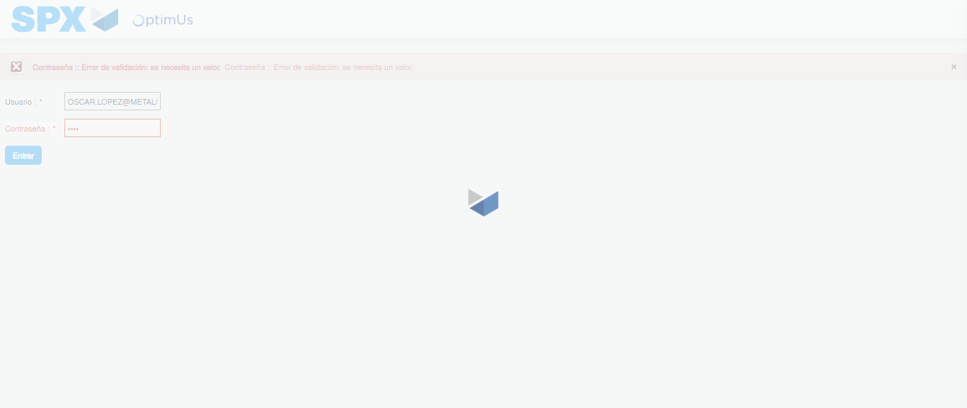Image file-name: QC_Testing-tc005_SPX_Dev5_Crear_Requisicion_Spot_Con_FAD_Tipo_Cobro_Project-1784572572719

Step 2 - Select to UEN and Access to Spot Buy Requisitions : UEN Correctly selected and Correct access
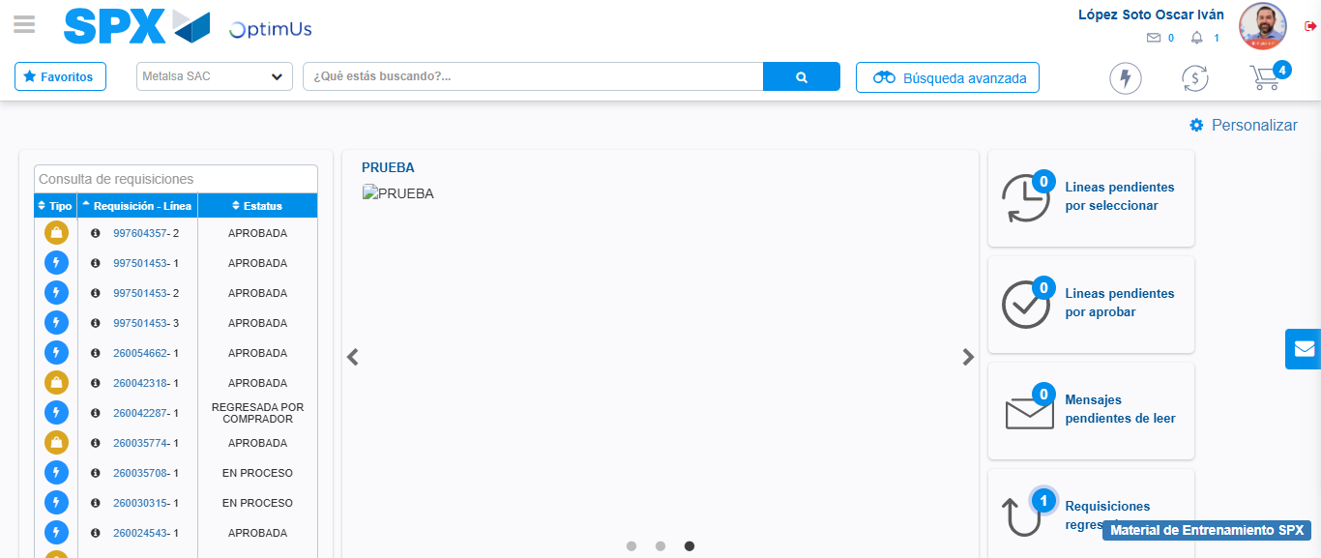Image file-name: QC_Testing-tc005_SPX_Dev5_Crear_Requisicion_Spot_Con_FAD_Tipo_Cobro_Project-1784572643683

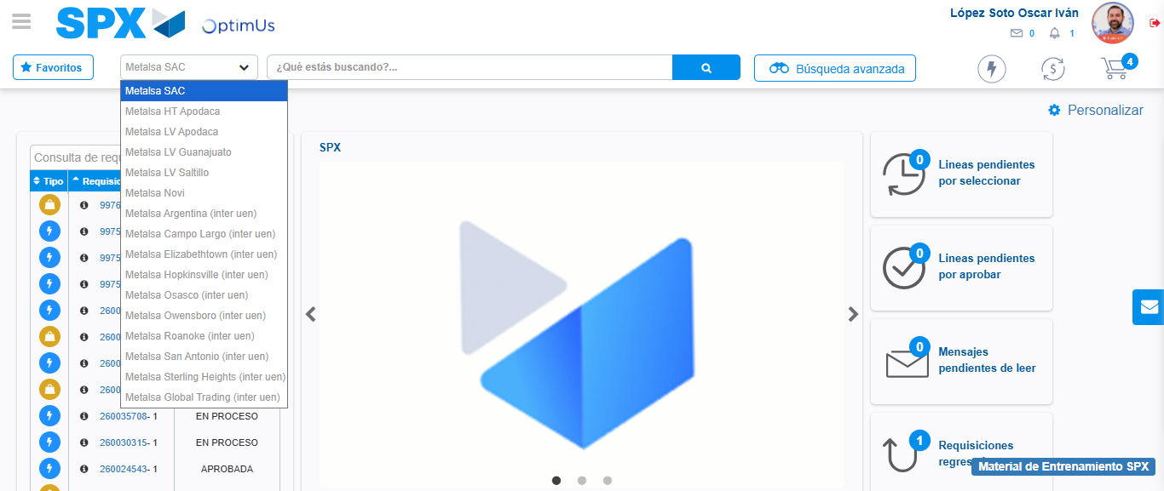Image file-name: QC_Testing-tc005_SPX_Dev5_Crear_Requisicion_Spot_Con_FAD_Tipo_Cobro_Project-1784572646633

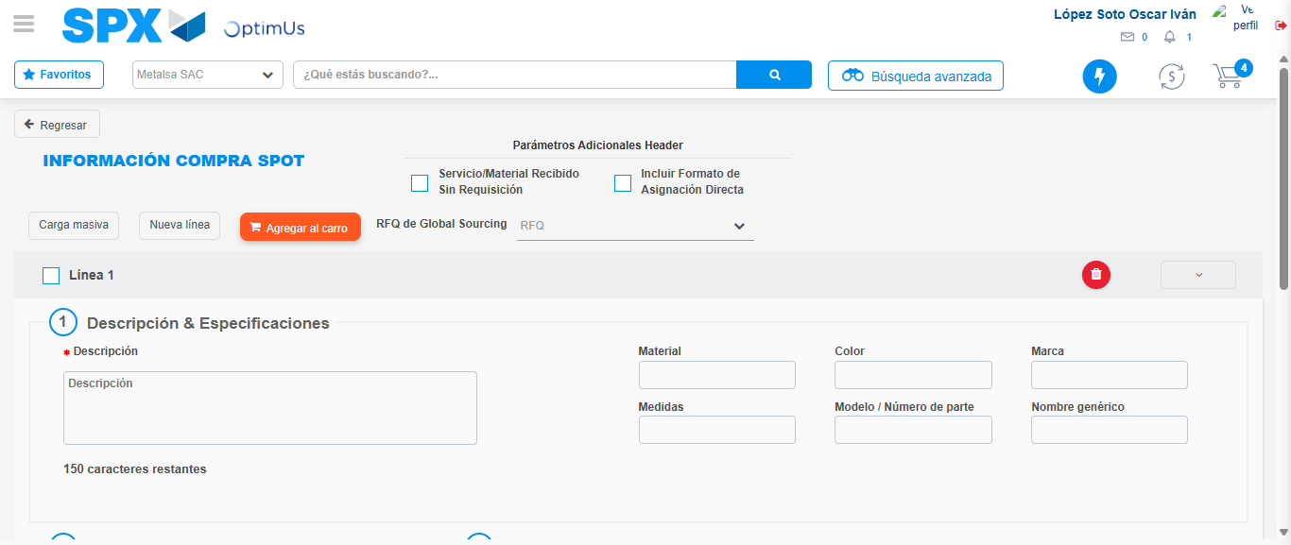Image file-name: QC_Testing-tc005_SPX_Dev5_Crear_Requisicion_Spot_Con_FAD_Tipo_Cobro_Project-1784572663268

Step 3 - Add FAD to Requisition: FAD Successfully Added
Image file-name: QC_Testing-tc005_SPX_Dev5_Crear_Requisicion_Spot_Con_FAD_Tipo_Cobro_Project-1784572663572

Image file-name: QC_Testing-tc005_SPX_Dev5_Crear_Requisicion_Spot_Con_FAD_Tipo_Cobro_Project-1784572663807

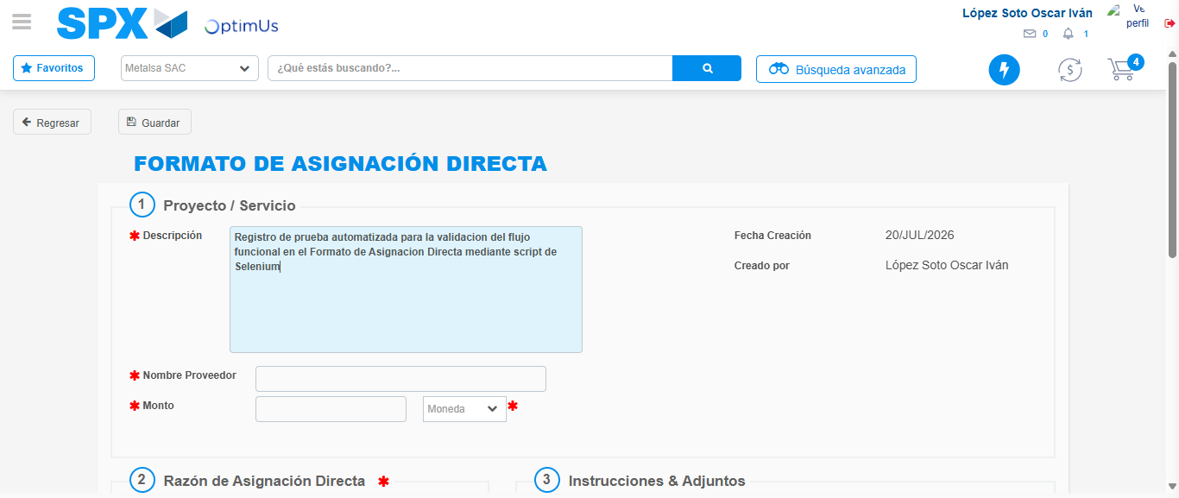Image file-name: QC_Testing-tc005_SPX_Dev5_Crear_Requisicion_Spot_Con_FAD_Tipo_Cobro_Project-1784572666918

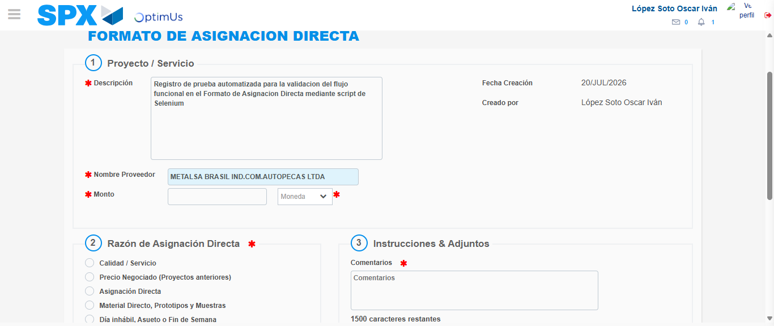Image file-name: QC_Testing-tc005_SPX_Dev5_Crear_Requisicion_Spot_Con_FAD_Tipo_Cobro_Project-1784572674293

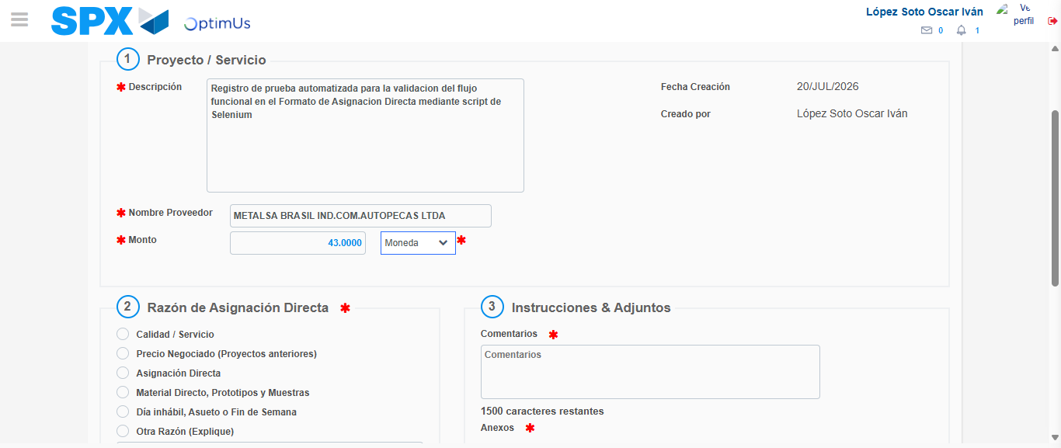Image file-name: QC_Testing-tc005_SPX_Dev5_Crear_Requisicion_Spot_Con_FAD_Tipo_Cobro_Project-1784572674832

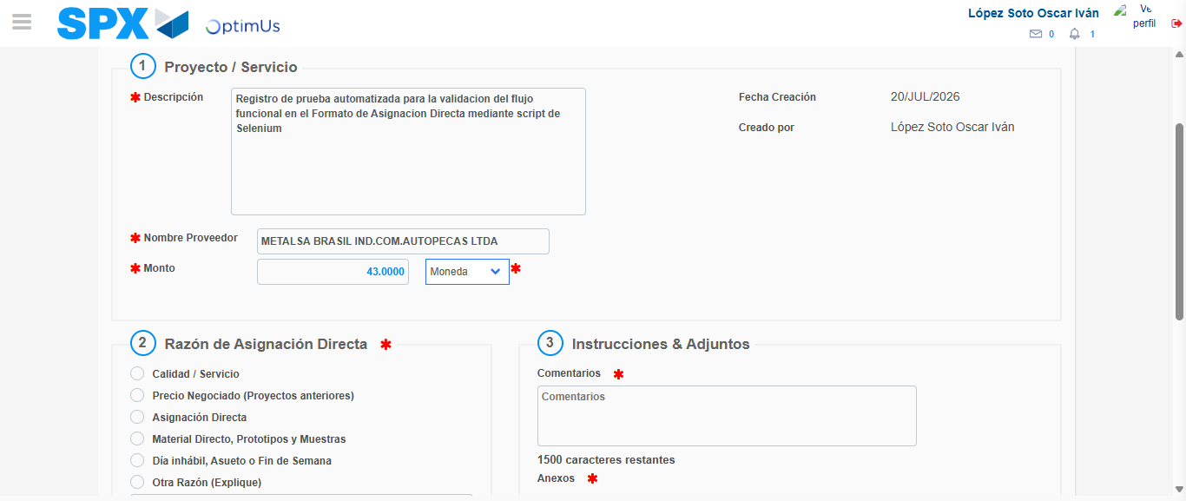Image file-name: QC_Testing-tc005_SPX_Dev5_Crear_Requisicion_Spot_Con_FAD_Tipo_Cobro_Project-1784572675120

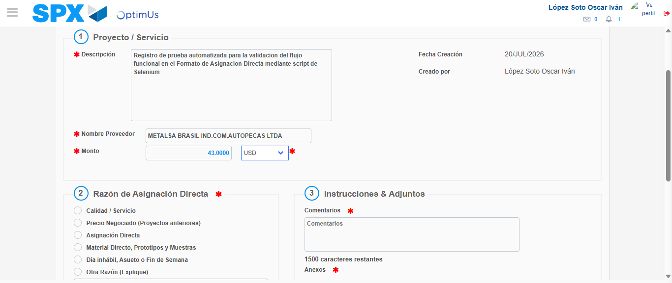Image file-name: QC_Testing-tc005_SPX_Dev5_Crear_Requisicion_Spot_Con_FAD_Tipo_Cobro_Project-1784572675578

Image file-name: QC_Testing-tc005_SPX_Dev5_Crear_Requisicion_Spot_Con_FAD_Tipo_Cobro_Project-1784572675869

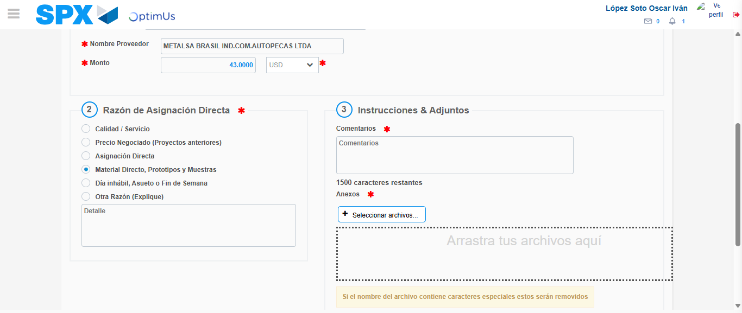Image file-name: QC_Testing-tc005_SPX_Dev5_Crear_Requisicion_Spot_Con_FAD_Tipo_Cobro_Project-1784572676865

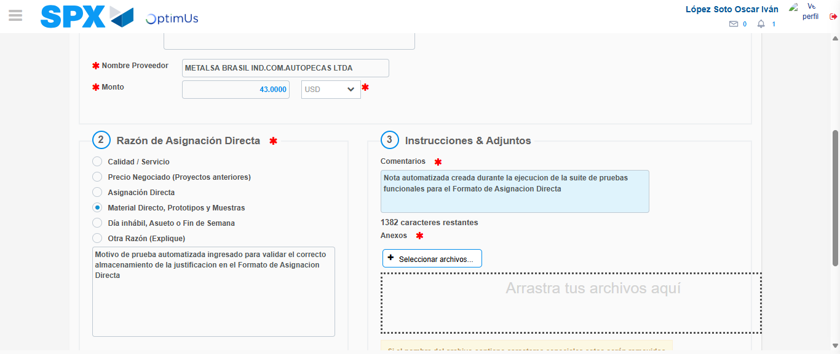Image file-name: QC_Testing-tc005_SPX_Dev5_Crear_Requisicion_Spot_Con_FAD_Tipo_Cobro_Project-1784572688362

Image file-name: QC_Testing-tc005_SPX_Dev5_Crear_Requisicion_Spot_Con_FAD_Tipo_Cobro_Project-1784572689305

Step 4 - Data Capture Spot Buy Requisition: Data captured correctly
Image file-name: QC_Testing-tc005_SPX_Dev5_Crear_Requisicion_Spot_Con_FAD_Tipo_Cobro_Project-1784572663572

Image file-name: QC_Testing-tc005_SPX_Dev5_Crear_Requisicion_Spot_Con_FAD_Tipo_Cobro_Project-1784572663807

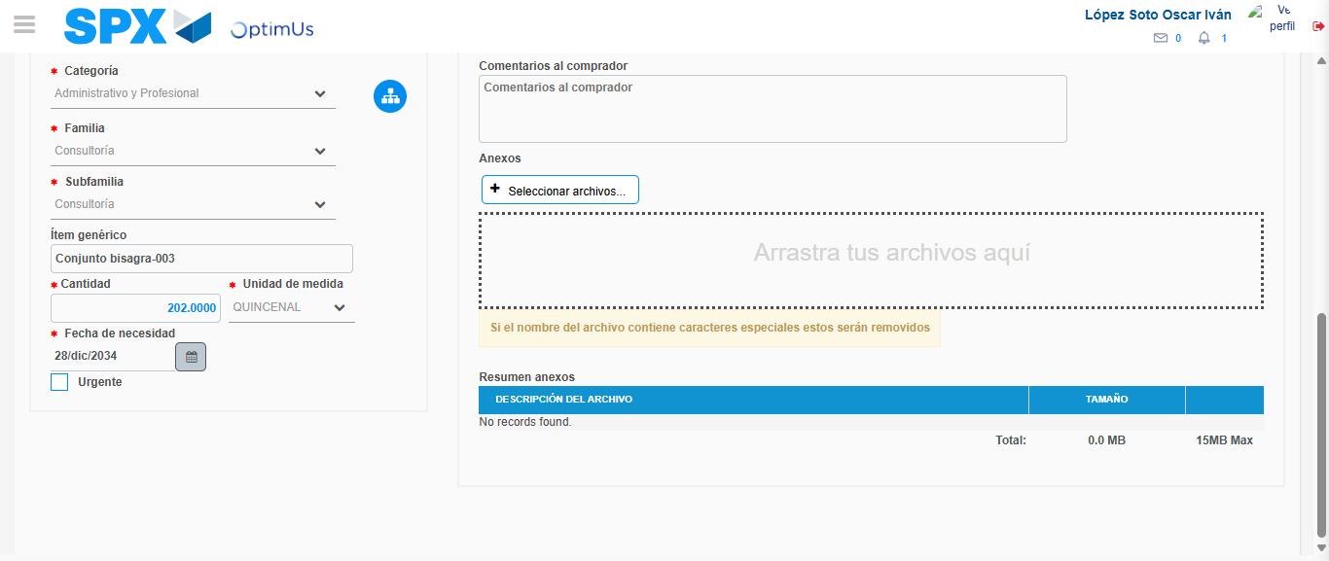Image file-name: QC_Testing-tc005_SPX_Dev5_Crear_Requisicion_Spot_Con_FAD_Tipo_Cobro_Project-1784572702286

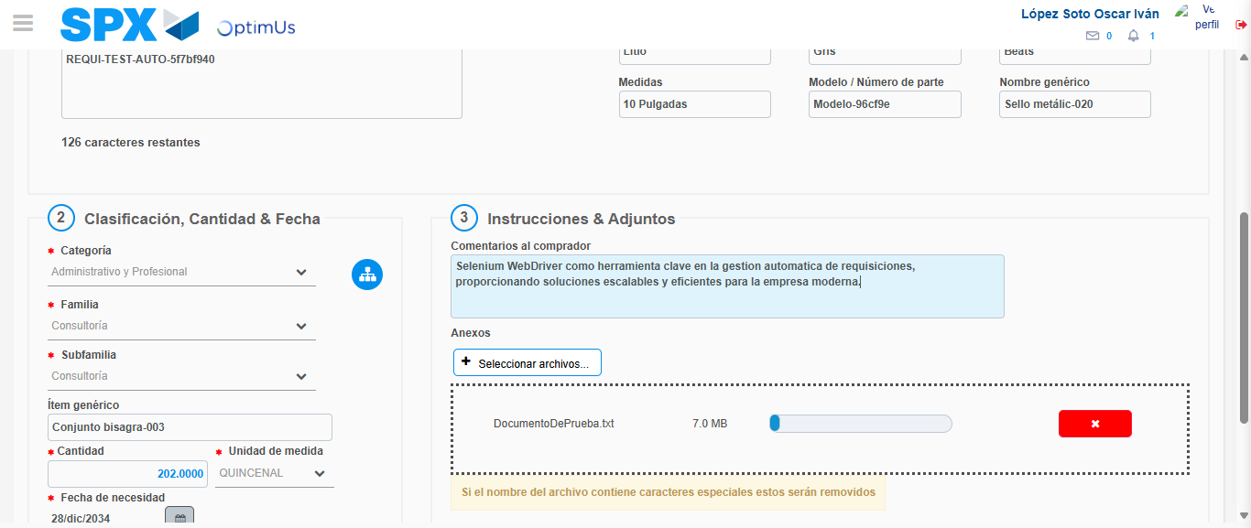Image file-name: QC_Testing-tc005_SPX_Dev5_Crear_Requisicion_Spot_Con_FAD_Tipo_Cobro_Project-1784572703073

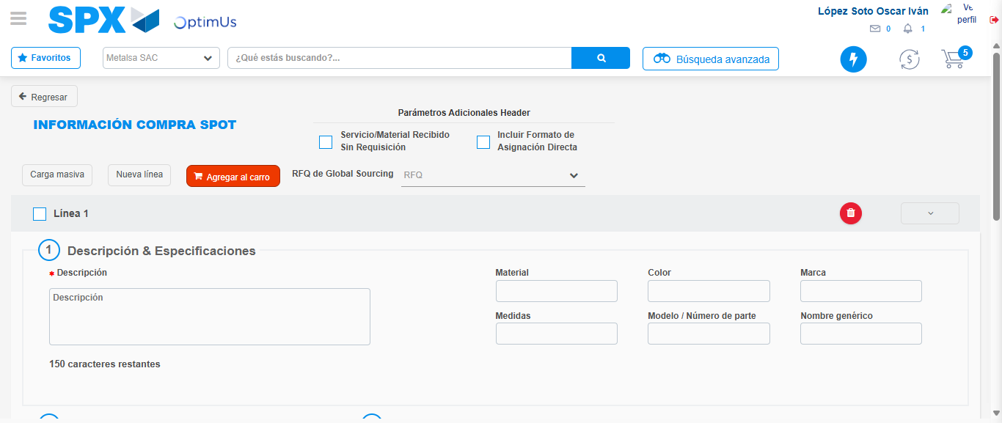Image file-name: QC_Testing-tc005_SPX_Dev5_Crear_Requisicion_Spot_Con_FAD_Tipo_Cobro_Project-1784572711496

Step 8 - Return to Main Page SPX : Return to Main Page SPX
Image file-name: QC_Testing-tc005_SPX_Dev5_Crear_Requisicion_Spot_Con_FAD_Tipo_Cobro_Project-1784572643683

Image file-name: QC_Testing-tc005_SPX_Dev5_Crear_Requisicion_Spot_Con_FAD_Tipo_Cobro_Project-1784572646633

Image file-name: QC_Testing-tc005_SPX_Dev5_Crear_Requisicion_Spot_Con_FAD_Tipo_Cobro_Project-1784572663268

Image file-name: QC_Testing-tc005_SPX_Dev5_Crear_Requisicion_Spot_Con_FAD_Tipo_Cobro_Project-1784572713731

Image file-name: QC_Testing-tc005_SPX_Dev5_Crear_Requisicion_Spot_Con_FAD_Tipo_Cobro_Project-1784572713906

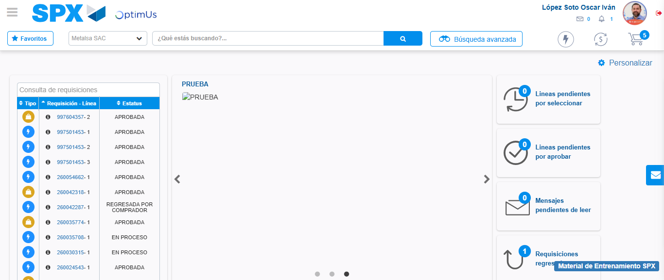Image file-name: QC_Testing-tc005_SPX_Dev5_Crear_Requisicion_Spot_Con_FAD_Tipo_Cobro_Project-1784572735297

Step 9 - Log Out : Log Out SPX
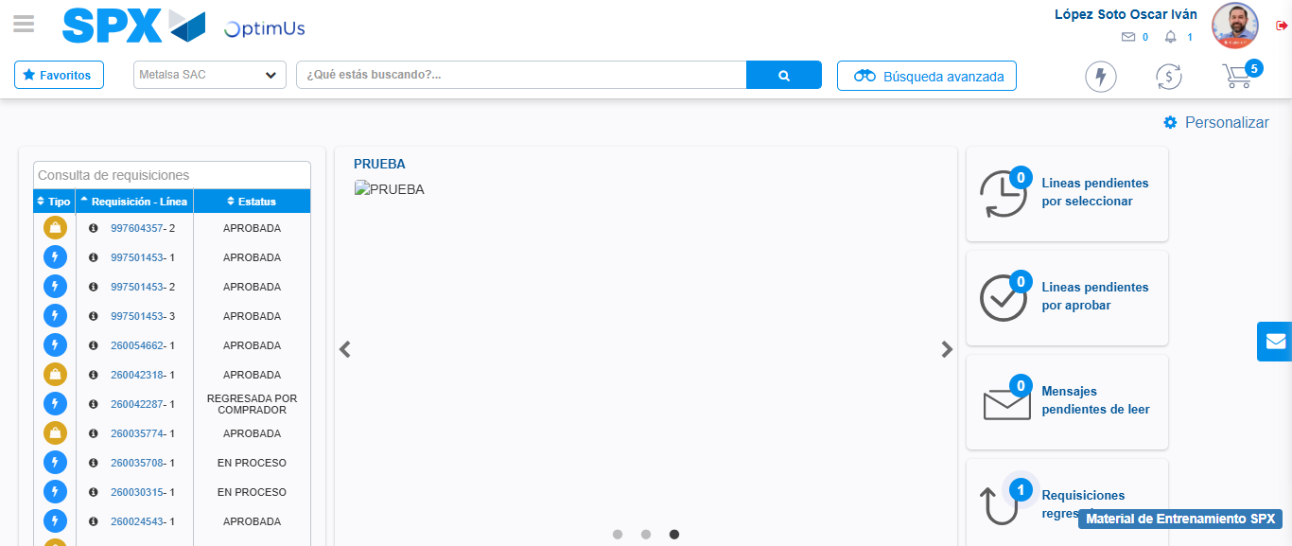Image file-name: QC_Testing-tc005_SPX_Dev5_Crear_Requisicion_Spot_Con_FAD_Tipo_Cobro_Project-1784572735581

